Chapter 5

Database Design

1. **Conceptual Database Design**

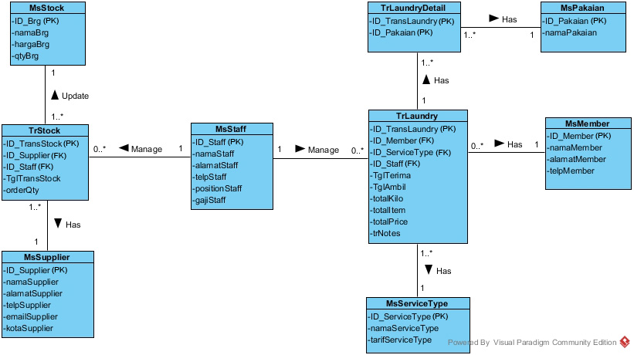

1. **Logical ER Modeling**

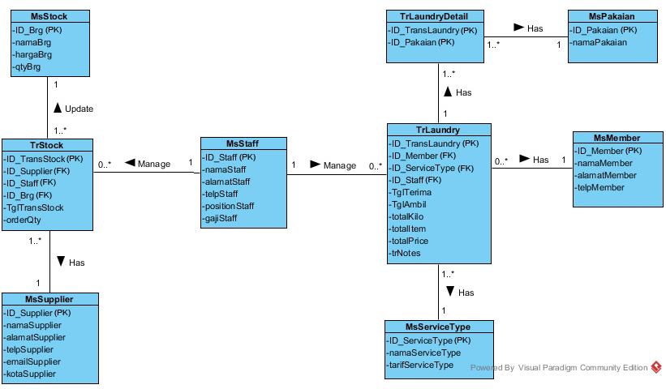

1. **Physical Database Design**

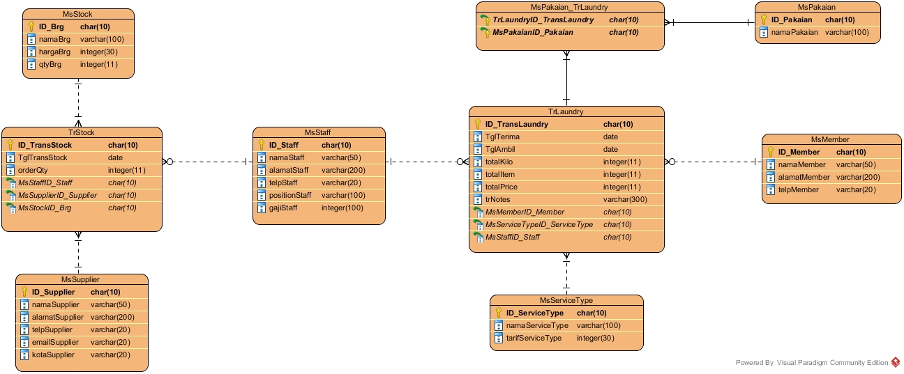

|  |  |  |  |  |  |  |  |  |  |  |  |  |  |  |  |  |
| --- | --- | --- | --- | --- | --- | --- | --- | --- | --- | --- | --- | --- | --- | --- | --- | --- |
| Transaction/ Relation | View Transaction | | | | Manage Member | | | | Manage Staff | | | | Manage Supplier | | | |
| I | R | U | D | I | R | U | D | I | R | U | D | I | R | U | D |
| TrLaundry |  | ● |  |  |  |  |  |  |  |  |  |  |  |  |  |  |
| MsMember |  |  |  |  |  | ● | ● | ● |  |  |  |  |  |  |  |  |
| MsServiceType |  |  |  |  |  |  |  |  |  |  |  |  |  |  |  |  |
| TrLaundryDetail |  |  |  |  |  |  |  |  |  |  |  |  |  |  |  |  |
| MsPakaian |  |  |  |  |  |  |  |  |  |  |  |  |  |  |  |  |
| MsStaff |  |  |  |  |  |  |  |  | ● | ● | ● | ● | ● | ● | ● | ● |
| TrStock |  |  |  |  |  |  |  |  |  |  |  |  |  |  |  |  |
| MsSupplier |  |  |  |  |  |  |  |  |  |  |  |  |  |  |  |  |
| MsStock |  |  |  |  |  |  |  |  |  |  |  |  |  |  |  |  |
| Transaction/ Relation | Data Stock | | | | Register Member | | | | Order Laundry | | | | Update Stock | | | |
| I | R | U | D | I | R | U | D | I | R | U | D | I | R | U | D |
| TrLaundry |  |  |  |  |  |  |  |  | ● |  |  |  |  |  |  |  |
| MsMember |  |  |  |  | ● |  |  |  |  | ● |  |  |  |  |  |  |
| MsServiceType |  |  |  |  |  |  |  |  |  | ● |  |  |  |  |  |  |
| TrLaundryDetail |  |  |  |  |  |  |  |  | ● |  |  |  |  |  |  |  |
| MsPakaian |  |  |  |  |  |  |  |  |  | ● |  |  |  |  |  |  |
| MsStaff |  |  |  |  |  |  |  |  |  | ● |  |  |  |  |  |  |
| TrStock |  |  |  |  |  |  |  |  |  |  |  |  | ● | ● | ● | ● |
| MsSupplier |  | ● |  |  |  |  |  |  |  |  |  |  |  | ● |  |  |
| MsStock |  | ● | ● |  |  |  |  |  |  |  |  |  |  |  |  |  |

1. **Cross-Referencing Transactions and Relations**
2. **Cross Referencing of Role**

|  |  |  |  |  |  |  |  |  |  |  |  |  |
| --- | --- | --- | --- | --- | --- | --- | --- | --- | --- | --- | --- | --- |
| Transaction/ Relation | Member | | | | Staff | | | | Owner | | | |
| I | R | U | D | I | R | U | D | I | R | U | D |
| TrLaundry | ● | ● |  |  | ● | ● | ● | ● | ● | ● | ● | ● |
| MsMember | ● | ● |  |  | ● | ● | ● | ● | ● | ● | ● | ● |
| MsServiceType |  | ● |  |  | ● | ● | ● | ● | ● | ● | ● | ● |
| TrLaundryDetail |  | ● |  |  | ● | ● | ● | ● | ● | ● | ● | ● |
| MsPakaian |  | ● |  |  | ● | ● | ● | ● | ● | ● | ● | ● |
| MsStaff |  | ● |  |  | ● | ● | ● | ● | ● | ● | ● | ● |
| TrStock |  |  |  |  | ● | ● | ● | ● | ● | ● | ● | ● |
| MsSupplier |  |  |  |  | ● | ● | ● | ● | ● | ● | ● | ● |
| MsStock |  |  |  |  | ● | ● | ● | ● | ● | ● | ● | ● |

1. **Normalization**

From Laundry Service Receipts

|  |  |
| --- | --- |
| UNF |  |
| TrLaundry | (**ID_TransLaundy**, namaStaff, TglTerima, TglAmbil, namaMember, alamatMember, telpMember, namaServiceType, tarifServiceType, {namaPakaian}, totalItem, totalKilo, totalPrice, trNotes) |
|  |  |
| 1NF |  |
| TrLaundry | (**ID_TransLaundy**, namaStaff, TglTerima, TglAmbil, namaMember, alamatMember, telpMember, namaServiceType, tarifServiceType, totalItem, totalKilo, totalPrice, trNotes) |
| TrLaundryDetail | (**ID_TransLaundry**, **ID_Pakaian**, namaPakaian) |
|  |  |
| 2NF |  |
| TrLaundry | (**ID_TransLaundy**, namaStaff, TglTerima, TglAmbil, namaMember, alamatMember, telpMember, namaServiceType, tarifServiceType, totalItem, totalKilo, totalPrice, trNotes) |
| TrLaundryDetail | (**ID_TransLaundry**, **ID_Pakaian**) |
| MsPakaian | (**ID_Pakaian**, namaPakaian) |
|  |  |
| 3NF |  |
| TrLaundry | (**ID_TransLaundy**, ID_Staff, ID_Member, ID_ServiceType, TglTerima, TglAmbil, totalItem, totalKilo, totalPrice, trNotes) |
| TrLaundryDetail | (**ID_TransLaundry**, **ID_Pakaian**) |
| MsPakaian | (**ID_Pakaian**, namaPakaian) |
| MsMember | (**ID_Member**, namaMember, alamatMember, telpMember) |
| MsStaff | (**ID_Staff**, namaStaff, alamatStaff, telpStaff, positionStaff, gajiStaff) |
| MsServiceType | (**ID_ServiceType**, namaServiceType, tarifServiceType) |

From Stock Purchase Orders

|  |  |
| --- | --- |
| UNF |  |
| TrStock | (**ID_TransStock**, TglTransStock, namaSupplier, namaStaff, namaBrg, totalHarga, orderQty) |
|  |  |
| 1NF |  |
| TrStock | (**ID_TransStock**, TglTransStock, namaSupplier, namaStaff, namaBrg, orderQty) |
|  |  |
| 2NF |  |
| TrStock | (**ID_TransStock**, TglTransStock, namaSupplier, namaStaff, namaBrg, orderQty) |
|  |  |
| 3NF |  |
| TrStock | (**ID_TransStock**, ID_Supplier, ID_Staff, ID_Brg, TglTransStock, orderQty) |
| MsStaff | (**ID_Staff**, namaStaff, alamatStaff, telpStaff, positionStaff, gajiStaff) |
| MsBarang | (**ID_Brg**, namaBrg, hargaBrg, qtyBrg) |
| MsSupplier | (**ID_Supplier**, namaSupplier, alamatSupplier, telpSupplier, emailSupplier, kotaSupplier) |

3NF from both Laundry Service Receipts and Stock Purchase Orders

|  |  |
| --- | --- |
| 3NF |  |
| TrLaundry | (**ID_TransLaundy**, ID_Staff, ID_Member, ID_ServiceType, TglTerima, TglAmbil, totalItem, totalKilo, totalPrice, trNotes) |
| TrLaundryDetail | (**ID_TransLaundry**, **ID_Pakaian**) |
| MsPakaian | (**ID_Pakaian**, namaPakaian) |
| MsMember | (**ID_Member**, namaMember, alamatMember, telpMember) |
| MsStaff | (**ID_Staff**, namaStaff, alamatStaff, telpStaff, positionStaff, gajiStaff) |
| MsServiceType | (**ID_ServiceType**, namaServiceType, tarifServiceType) |
| TrStock | (**ID_TransStock**, ID_Supplier, ID_Staff, ID_Brg, TglTransStock, orderQty) |
| MsBarang | (**ID_Brg**, namaBrg, hargaBrg, qtyBrg) |
| MsSupplier | (**ID_Supplier**, namaSupplier, alamatSupplier, telpSupplier, emailSupplier, kotaSupplier) |